**Face Detection and Face Recognition**

In this project is divided into following sub tasks:

1. **Image processing :**
2. **Video processing :** video processing consists processing of number of image
3. **Real time processing** : This include continuous processing of images
4. **Image processing**: For image processing, consider only one image.
5. Capture the image using pi camera rev 1.3
6. Detect the multiple faces from captured image
7. Crop the face detected from image
8. Save the crop image

In this, I have captured the image using camera as shown below.

1) Expected result 2) Unexpected result

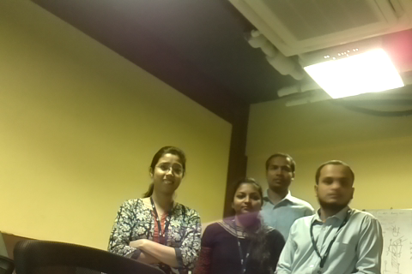 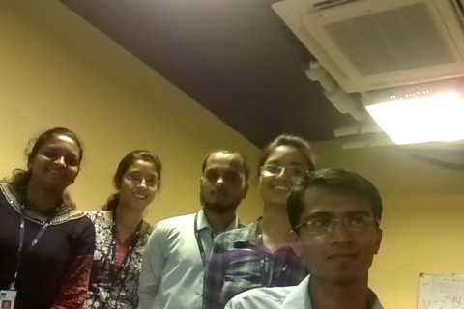

Image 1 – capture image

Rectangular box for all detected faces

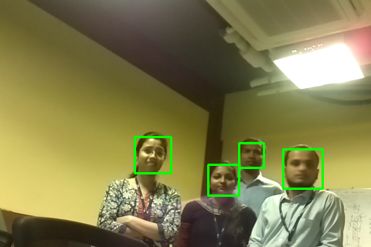 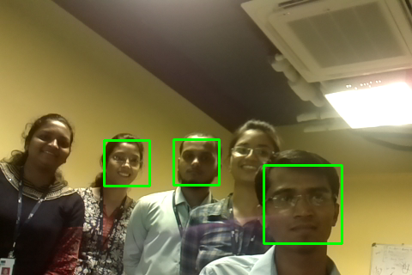

All faces are detected image only three faces are detected

---------------------------Crop images------------------------------

I have croped the faces and saved it.

C:\Users\patilp02\Documents\My Received Files\crop_image309.png C:\Users\patilp02\Documents\My Received Files\crop_image269.png C:\Users\patilp02\Documents\My Received Files\crop_image121.png C:\Users\patilp02\Documents\My Received Files\crop_image366.png C:\Users\patilp02\Documents\My Received Files\crop_image202.png  C:\Users\patilp02\Documents\My Received Files\crop_image174.png

**Conclusion:**

1. As shown above, in IMAGE1 we got expected results but not in IMAGE 2.
2. Face detection process working depends on :
3. Camera
4. Light intensity
5. Processor speed
6. Change in pose and change in expression
7. Changing appearance with varying illumination
8. Change in image position and scale factor
9. Set of weak classifier present in Opencv framework
10. Environmental parameter

As detection is affected by these many factors. Even small change will not going to detect face. That’s why in IMAGE2 we are not able to detect all faces.

If all these factors are affecting face detection for single image. In case of video and real time scenarios probability of occurrence of these problem increases as it is collection of images. Hence in real time scenarios, we cannot give guaranty that every time it will give the correct result.

As face detection is not accurate so face recognition gets affected.so we will not get correct output.

Hence the task which I have completed until now, sometimes it gives accurate result and sometime it gives unexpected result.